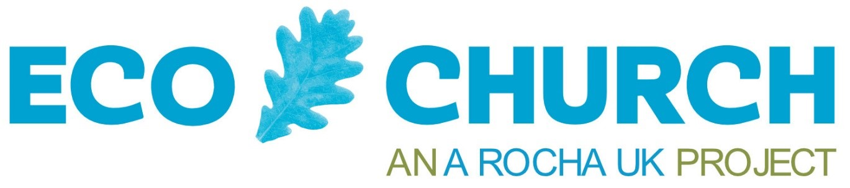
Eco District status will be given to your District when it has achieved and can demonstrate evidence of the following:
Please provide dates where applicable and copies of materials to support the application.
1. Registered its intent to become an Eco District. | A Rocha UK Office Use: Y / N
2. Commissioned an individual or group to coordinate progress within the District | Name and contact details for individual or group and short description of groups purpose.
3. Written an environmental policy | Attach copy or provide web link to agreed policy.
4. Gained the appropriate levels of local  church registrations and Awards for Eco  Church | Provide details in the separate application form:  - How many churches are there in your District?  - How many of these churches are registered with Eco Church?  - How many churches are at a Bronze award?  - How many churches are at a Silver award?  - Please also send a file of all your registered churches with Church name, town and postcode and indicate which Eco Church award achieved.
5. Achieved the relevant Eco Church Award  level ‘In relation to its District Office. In the  Buildings category (where appropriate) and  Land (where appropriate). | Address of District Office, date when Bronze Award achieved and additional comments:
6. Embedded environmental issues in ongoing  training. Have sought to ensure that  environmental issues are embedded within  the curricula of ongoing presbyterial and local  preacher education and support. | Provide evidence (dates & brief details). For example, by ensuring that local preachers have access to materials to support theological reflection on our care for God’s creation.
7. Managed District investments ethically with  due consideration to the environmental  implications / opportunities of such  investments, taking into account the climate  change investment policy of the Central  Finance Board of the Methodist Church and  the resources available within the Your Faith  Your Finance project. | Provide evidence of ethical investment:
8. Worked with other Districts and / or faith  groups ‘to encourage greater environmental  action, including promoting Eco Church as  a helpful tool’. | Evidence of joint meetings, events and initiatives:
9. Established the habit of recording and  celebrating individual environmental  initiatives. | Evidence of District news, local media articles, promotional videos etc.

Policy. That has been agreed by Synod. Evidence can be in the form of a signed policy or an e-mail from Synod acknowledging and supporting the policy. The policy should include, where appropriate, points on travel, the environmental performance of Manses (re: Methodist Church standing order guidelines on Energy Performance Certificates) and a commitment to reducing carbon emissions.
If a District office is based in a Methodist Church, it is expected that this Church would have achieved a Bronze Eco Church award. In addition to help us review your application please go through the Building questions that pertain to the operational aspects of the Circuit office to share the eco initiatives that take place within an office environment. Do consider sharing if there are other areas that you may be able to influence e.g. helping the church measure their carbon footprint and set targets etc. As well as things you have been able to do within your office environment such as switching to all LED bulbs in the circuit office, using recycled paper, and recycled toilet paper and looking to measure your carbon footprint etc. We are generally seeking to understand about awareness and intentionality of being more sustainable within your circuit office setting or how the admin staff, wherever they are based, operate within the ethos of the Eco Church survey (seeking to be environmentally aware and sustainable to express our care for Gods world).
For example through the Learning Network Regions. There are different options for local preachers to have access to materials to support theological reflection on our care for God’s creation. See the Methodist Church Worship: Leading & Preaching course, Singing the Faith Plus resources, and Eco Church “Worship and Teaching” resources.

