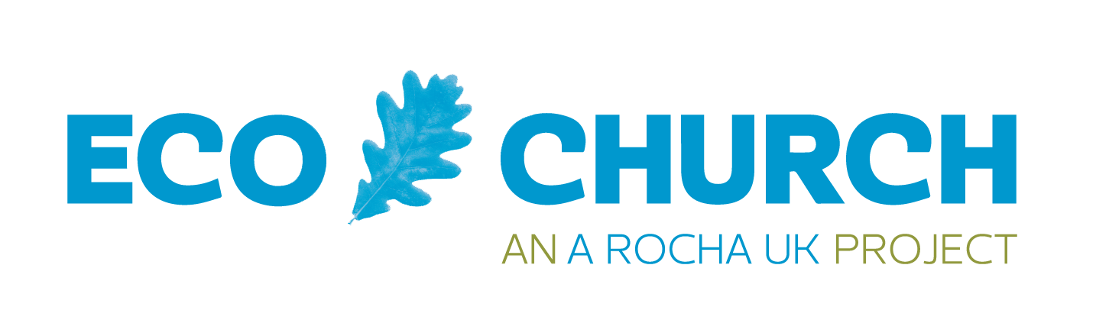
Gold Award supporting evidence pro forma

Why do I need to supply extra evidence for a gold Eco Church award?

Applying for a gold award involves some extra steps, beyond the Eco Church survey because:

- We want to be sure that the ethos of Eco Church is embedded in your worshiping community
- We need to see some key documentation and processes are established within your church
- We want to hear your story so we can share it to encourage others

How do I apply for a gold Eco Church award?
- Complete the online survey (reaching gold in all categories) and submit your application
- Complete the this pro forma and email it, with the additional documents, to ecochurch@arocha.org
For a reminder of your gold Eco Church survey answers click here.

What happens next?
Once we have received your online application, this pro forma and additional documents we will review your application and supporting evidence. If we have any questions or points to clarify we will get in touch. Once we are satisfied that all the criteria have been met we will then arrange a meeting (in person or online) to complete the assessment. We will then confirm your award via an email.

Checklist
- Reached gold in all categories of Eco Church survey and submitted on the platform
- All sections of this pro forma have been completed (In addition to your comments you may include weblinks to online content and embed digital photos.)
- Attach your latest carbon footprint report (our preference is your 360 Carbon report)
- Attach your church’s nature/land management plan

Please send this completed document and additional documents to ecochurch@arocha.org

Your church’s name, address and website.

Tell us a little about your church - its people, building, location and local community. (500 words max)

Who is on your Eco Church team?

Please share some examples of how you are promoting Eco Church via your website/ social media and other communication opportunities.

How and why did you start on your Eco Church journey? (500 words max)

Can you share some examples of the impact Eco Church has had on your church and your wider community?

If a visitor walked into your church building or took part in a church Sunday or a mid-week service - how would they know you are an Eco Church?

Share some examples of how Eco Church/ Creation care principles are embedded in your church life and community outreach.

How are you influencing others around you (locally/regionally/nationally) to address the nature and climate crisis?

Worship and Teaching (500 words max)
What was the biggest challenge in working towards gold in this category?

What was the highlight in working towards gold in this category?

Building management (500 words max)
After measuring your church’s carbon footprint, what steps did you take to reduce it?

What were some challenges you faced in working towards gold in this category?

What were some highlights of working towards gold in this category?

Land: Protecting and restoring nature (500 words max)
Share some learnings from your land management plan/ Churches plan for nature?

What were some challenges you faced in working towards gold in this category?

What were some highlights of working towards gold in this category?

Community and Global Engagement (500 words max)
What were some challenges you faced in working towards gold in this category?

What were some highlights of working towards gold in this category?

Lifestyle (500 words max)
What were some challenges you faced in working towards gold in this category?

What were some highlights of working towards gold in this category?

Growing beyond gold (500 words max)
How is your church planning to continue its Eco Church journey?

How would you celebrate a gold award?

Please leave this box blank for the Eco Church team
Feedback from Eco Church gold review

